**PROJECT DEVELOPMENT DELIVERY OF SPRINT**

**-**

**2**

TEAM ID

PNT2022TMID53973

PROJECT NAME

SMART SOLUTIONS FOR RAILWAYS

DATE

14/11/2022

Proposed architecture for smart track monitoring

system.

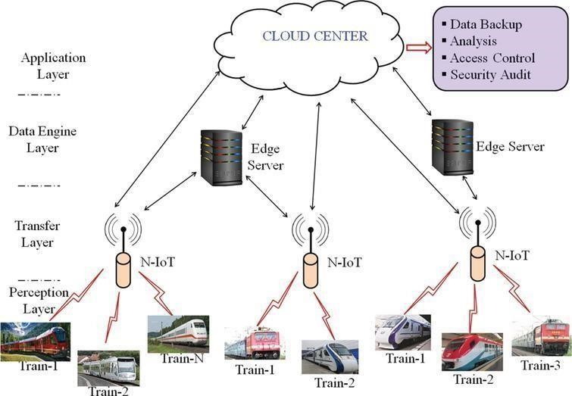

Structural health monitoring of railway tracks using

IOT

-

based multi robot system:

